EcoSand Cleaner: Automated Beach Debris Cleaner

Submitted by:

Balimbingan, Shaina F.
Dacatimban, Kristine Jewel M.
Dado, Kenneth S.
Fajutagana, Kimberly A.
Fernandez, Robyn Kristoffer P.

May 2026
Table of Contents

Project Overview 3
Problem Statement 3
Scope of the Study 4
System Architecture 5
Architecture Description 5
Data Flow 6
Hardware Components 8
Database Design 13
System Operation Procedure 15
Gantt Chart 18
Expected Output 21

Project Overview
Beaches in the Philippines, are super dirty because of plastic waste and trash washing in from the sea think bottles, bags, fishing nets, and tiny microplastics. The Department of Environment and Natural Resources (DENR, 2023) reports a whopping 1.5 million tons of marine debris hitting Philippine shores yearly, mostly plastics that don't break down. This hurts fish and animals they eat it or get tangled, kills off sea turtles and corals, and makes tourism worse since no one wants to visit trashy beaches. In areas near Quezon City like Manila Bay or nearby coastal spots in Cavite and Bataan, pollution is extra bad from urban runoff and rivers dumping city waste straight into the sea (Jambeck et al., 2015). Cleaning by hand takes forever workers spend hours raking sand, it's really tiring (leading to back pain and injuries, as shown in Villanueva et al., 2021), and it misses small pieces of trash buried 5-10 cm deep in the sand. Big industrial machines like tractors with rakes exist but cost hundreds of thousands of pesos and damage beach dunes (Earthwatch, 2019). To address this, the EcoSand Cleaner: Automated Beach Debris Cleaner was developed as a low-cost and semi-mechanized solution. The system is operated using a 2.4GHz RC transmitter and receiver for manual control. An ESP32 microcontroller processes control signals and manages system operations. The system uses DC motors for movement and a vibration motor with a wire mesh to separate sand from debris. Collected waste is stored in an onboard collection bin, while sensors such as IR and soil moisture sensors assist in obstacle detection and environmental monitoring. The system is powered by a 12V battery with solar charging support and is designed to help barangays clean beaches more efficiently and sustainably.

Problem Statement
Coastal areas are increasingly affected by improper waste disposal and environmental pollution, resulting in the continuous accumulation of debris along shorelines. Existing beach cleaning practices are primarily manual, making them labor-intensive, time-consuming, and often ineffective in addressing small and partially buried waste. These challenges highlight the need for an efficient, safe, and sustainable automated solution for coastal waste management.
Specifically, this study seeks to answer the following problems:
- How can beach cleaning be made more efficient and less labor-intensive?
Manual cleaning requires significant time and effort, especially in large coastal areas, creating a need for an automated cleaning system.
- How can small and partially buried debris be effectively collected?
Traditional cleaning methods often fail to remove small to medium-sized waste materials such as plastics, bottle caps, and cigarette butts, which remain embedded in the sand.
- How can health and safety risks to cleaners be minimized?
Manual cleaning exposes individuals to hazardous waste, sharp objects, and prolonged environmental exposure, necessitating a safer, automated approach.
- How can coastal pollution be reduced through continuous and efficient cleaning?
Waste accumulation caused by improper disposal and ocean currents requires a system capable of maintaining cleaner shorelines over time.
- How can operational costs in beach cleaning be reduced?
Frequent clean-up operations involve recurring expenses in labor, equipment, and transportation, highlighting the need for a cost-effective solution.
- How can continuous and automated cleaning be implemented in coastal areas?
Most current efforts rely on scheduled clean-up drives rather than a system capable of regular or ongoing operation.
- How can automation and smart technologies be integrated into beach cleaning systems?
There is limited use of automated technologies in coastal waste management, indicating the need for an innovative system with monitoring and control capabilities.
General Objective
Generally, this study aims to design and develop the EcoSand Cleaner, an automated beach debris cleaning system that improves efficiency, enhances safety, and promotes sustainability in coastal waste management through the use of automation technology.
Specifically, it aims to
- To design and develop a semi-autonomous beach debris cleaning prototype that improves efficiency and reduces manual labor in shoreline cleaning.
- To develop a mechanical filtration and collection system capable of separating sand from small to medium solid waste materials.
- To implement an automated debris collection mechanism that minimizes direct human contact with hazardous and contaminated waste.
- To incorporate a dual-mode charging system using solar panels and Type-C input to ensure continuous and flexible power supply.
- To create a local web-based interface for monitoring system performance and viewing real-time cleaning data.
- To deploy a cost-effective and reusable prototype intended to support local beach cleaning operations within defined environmental and operational limits.

Scope and Delimitations

This study shows the design and development of the EcoSand Cleaner, an automated beach debris cleaning system. The automation of the collection process is designed to enhance the efficiency of cleaning in shorelines by mechanically separating the sand from solid waste. It focuses on gathering small to medium-sized waste like plastics, bottle caps, cigarette buttds, and partially buried wastes. The unit is designed to operate at a slow but controlled speed of up to 4 km/h for sufficient filtration and safe semi-autonomous navigation of the designated beach areas while mainly targeting to minimize human labor and human contact with hazardous materials. The development of the system is thus primarily aimed at cleaning beach areas from debris without direct human interaction. The system also features a dual-mode charging feature that enables the battery to be replenished using the integrated solar panels for a more field-sustainable mode of charging or through a Type-C charging feature for a faster charging cycle. A local web-based administrative interface is also included to enable users to manage the associated records and monitor real-time cleaning records through a web-based browser in the same network as the unit.
There are several limitations to this study, and the design limitations are apparent as a result of the research purpose. First, the system is only capable of operating under proper weather conditions, for example sun-drenched, in order to maximise solar charging and allow the vehicle to move at optimal efficiency across dry sand. As such, the vehicle’s functionality may dwindle greatly upon contact with very wet and damp sand or under water. Additionally, the vehicle’s size limits its efficiency in collecting large amounts or especially sized solid waste with large and/or massive solid debris such as heavy metallic objects and driftwood. It is not capable of collecting liquid forms of pollution or oil spills. The vehicle requires a stable input of 12V DC, thus its operational time is limited by the 20000mAh battery capacity and required charge time. On a larger scale, remote access is only limited by the local Wi-Fi network range created by the ESP32 or router. Finally, the system was built and designed for a semi-autonomously navitated in a flat beach terrain and manual intervention may be required in response when navigating across steep slopes and/or uneven terrain.

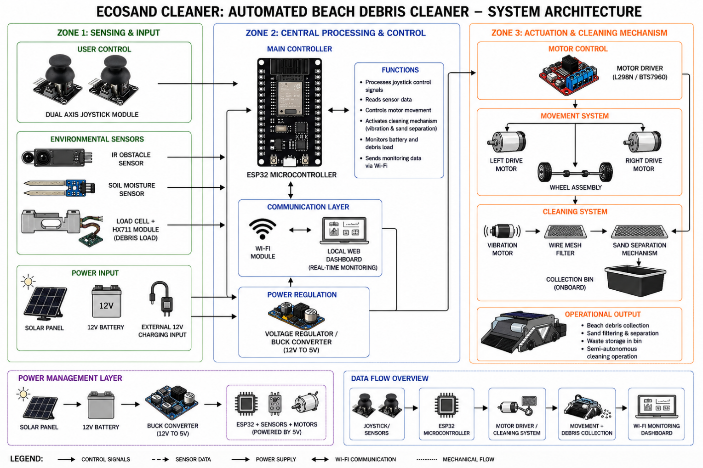
System Architecture

Figure 1. System Architecture

Architecture Description
Figure 1 shows the system architecture of the EcoSand Cleaner: Automated Beach Debris Cleaner is designed using a multi-zone structure composed of sensing and input, central processing and control, and actuation and cleaning mechanisms to ensure efficient and semi-automated beach cleaning operations. In the sensing and input zone, a dual-axis joystick module allows the user to manually control the system, while sensors such as the IR obstacle sensor, soil moisture sensor, and load cell with HX711 module collect environmental and operational data including obstacle detection, sand condition, and debris load measurement. These inputs are transmitted to the ESP32 microcontroller located in the central processing and control zone, which serves as the main controller responsible for processing sensor data, managing motor movement, activating the cleaning mechanism, monitoring battery and debris status, and transmitting real-time information through the built-in Wi-Fi module to a local web dashboard for monitoring purposes. The system is powered by a 12V battery supported by a solar panel and external charging input, while a voltage regulator or buck converter ensures stable power distribution to all components. In the actuation and cleaning mechanism zone, the ESP32 sends control signals to the motor driver, which controls the left and right drive motors for movement, while the vibration motor activates the wire mesh filtering mechanism that separates sand from collected debris and transfers waste materials into the onboard collection bin. Overall, the system operates through a continuous flow of sensing, processing, movement, cleaning, and monitoring to provide an efficient, cost-effective, and environmentally sustainable solution for automated beach debris collection.

Data Flow
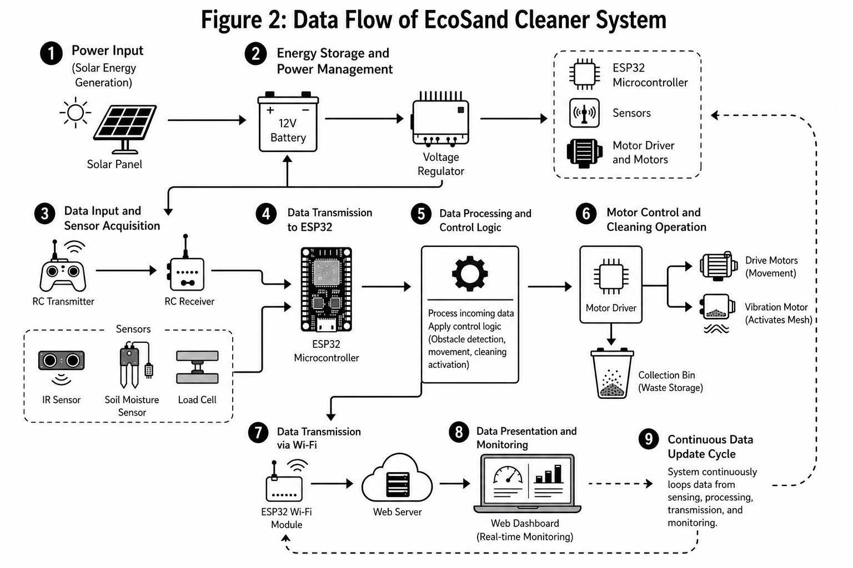

Figure 2: Data Flow

Figure 2 show the data flow of the EcoSand Cleaner System follows a structured path: power input → energy storage and management → data input and sensing → data transmission to ESP32 → data processing and control → motor operation and cleaning → data transmission via Wi-Fi → web-based monitoring. This flow helps the system operate smoothly, manage power properly, and provide accurate and real-time updates, as explained below:
- Power Input
The system starts with the solar panel. It collects sunlight and turns it into electrical energy that will be used to run the whole system.
- Energy Storage and Power Management
The energy from the solar panel is stored in a 12V battery. A voltage regulator makes sure the power is steady and safe before it is sent to the other parts.
- Data Input and Sensor Acquisition
The user can control the system using RC transmitter, and the signal is received by the RC receiver.
At the same time, sensors gather information from the environment.
- The IR sensor checks for obstacles
- The soil moisture sensor checks if the sand is wet or dry
- The load cell measures how much waste is collected
- Data Transmission to ESP32
All the signals from the controller and sensors are sent to the ESP32 micro-controller, which acts as the main brain of the system
- Data Processing and Control Logic
The ESP32 reads and understands the data. It decides what the system should do like avoiding obstacles, moving in a direction, or starting the cleaning process
- Motor Control and Cleaning
After deciding what to do, the system sends signals to the motor driver.
- The drive motors move the cleaner
- The vibration motor shakes the mesh to separate waste from sand
- The waste is collected in the bin
- Data Transmission via Wi-Fi
The ESP32 sends data through its Wi-Fi module to a web server so it can be viewed online
- Data Presenting and Monitoring
The data is shown on a web dashboard where users can see the system status, sensor readings, and cleaning activity in real time

Hardware Components

Component | Description | Minimum Requirements | Recommended Requirements
Microcontroller | Main control unit with WiFi/Bluetooth | ESP8266 | ESP32
Motor Driver | Controls DC motors | L298N | BTS7960 High-Power Driver
RC Transmitter & Receiver | Wireless control system | Standard 2.4GHz RC System | Long-range 2.4GHz RC System
Drive Motor | Powers the RC car wheels | 6V DC Motor | 24V 250W DC Motor
775 DC Motor | Conveyor or auxiliary motor | Standard DC Motor | 775 High-Speed DC Motor
Vibration Motor | Sand shaking/agitating mechanism | 6V DC Motor | 12V/24V DC Motor with Offset Weight
Servo Motor | Controls steering or mechanism movement | Standard Servo Motor | High Torque Servo Motor
Solar Panel | Charges battery for continuous operation | 100W Solar Panel | 200W Solar Panel
Battery / Power Supply | Main power source | 12V 20Ah Battery | 24V High-Capacity Battery / LiFePO4 Battery
Voltage Regulator | Steps down voltage safely | LM7805 | Buck Converter Module / XL4015E
Buck Converter | Adjustable voltage regulation | 5A Step-down Converter | XL4015E Adjustable Converter
IR Obstacle Sensor | Detects nearby obstacles | Standard IR Module | Adjustable IR Module
Soil Moisture Sensor | Detects wet sand | Analog Soil Sensor | Capacitive Soil Moisture Sensor
HX711 Module | Amplifies load cell readings | HX711 | HX711 Precision Module
SW-420 Vibration Sensor | Detects vibration or movement | Standard SW-420 | High Sensitivity SW-420
Wire Mesh Screen | Filters and sifts sand | 5mm Mesh | 3–4mm Stainless Mesh
Collection Bin | Stores collected debris | Plastic Container | Reinforced Removable Bin
PCB Board | Circuit prototyping board | 7x9 cm PCB Board | Reinforced PCB Board
Jumper Wires | Circuit connections | Male-Male | Male-Male & Male-Female
Male-to-Female Wires | Flexible circuit connection | Standard Wire | Durable Dupont Wires
Terminal Block / Bus Bar | Secure wire connections | Standard Terminal Block | Brass Bus Bar Terminal
Fuse Box & Fuse | Electrical protection | Standard Fuse | 4-Way ATO Fuse Box
Soldering Tools | Circuit assembly tools | Solder Paste & Flux | 60W Electric Soldering Iron
RC Car Tires | Wheel system for movement | Standard Rubber Tires | Heavy Duty Rubber Tires
360° Wheels/Casters | Additional movement support | Standard Casters | Heavy Duty Casters
Rubber Push Tire | Mobility support | Standard Rubber Tire | Heavy Duty Push Tire
Sprocket & Chain | Power transmission mechanism | Standard Sprocket | Reinforced Sprocket & Chain
Conveyor Steel Bars | Supports conveyor assembly | Mild Steel Bars | Reinforced Steel Bars
Wire Mesh / Screen | Sand filtering mechanism | 5mm Mesh | Stainless Steel Fine Mesh
Metal Sheet & Pipe | Main chassis and frame | Standard Sheet Metal | Reinforced Steel Pipe Frame
RL Bar | Structural reinforcement | Standard Bar | Heavy Duty Reinforcement Bar
Bolts & Fasteners | Secures mechanical parts | Standard Bolts | Heavy Duty Bolts & Nuts
Spray Paint | Surface finishing and protection | Standard Paint | Anti-rust Spray Paint

Table 1. Hardware Components

Software Requirements

Software | Purpose |  | Minimum Requirements | Recommended Requirements
Arduino IDE | Write and upload code to ESP32/ Arduibo |  | Arduino IDE | Arduino IDE/ PlatformIO
Programming Language (C/C++) | Develop system logic and control |  | Basic C/C++ knowledge | Advanced C/C++ with libraries
ESP32 Board Package | Enables ESP32 support in IDE |  | ESP32 core installed | Latest ESP32 core version
Ultrasonic Library (NewPing) | Controls ultrasonic sensor |  | NewPing library | Updated & optimized version
HX711 Library | Reads load cell data |  | HX711 Library | Calibrated HX711 Library
Motor Driver Library | Controls DC motors |  | Basic PWM code | Advanced motor control library
Serial Monitor | Debugging and data monitoring | Arduino Serial Monitor |  | Serial Plotter/ External Debug Tool
Wi-Fi/Bluetooth Library | Enables wireless communication | Basic Wi-Fi setup |  | Web server/ Mobile app integration

Table 2: Software Components

Functional Requirements
This section discusses the core functional requirements of the EcoSand Cleaner: Automated Beach Debris Cleaner system. Each requirement defines a specific behavior that the system must perform to ensure efficient, safe, and practical beach cleaning within the defined scope of the prototype.
1. The system shall support manual detection and collection of beach debris
The EcoSand Cleaner system shall allow the operator to manually navigate the prototype toward visible small to medium beach debris using the wireless RC controller. The cleaning mechanism shall collect surface-level waste materials through the conveyor, vibration motor, and wire mesh filtering system during operation. The system is intended to collect commonly visible debris such as plastics, wrappers, bottle caps, and similar lightweight waste materials found on dry sand surfaces.
2. The system shall mechanically collect, filter, and separate debris from sand
The system shall utilize a conveyor mechanism, vibration motor, wire mesh screen, and collection system to separate debris from sand. The vibration motor shall agitate the mesh screen to allow fine sand particles to pass through while retaining larger waste materials such as plastics, bottle caps, paper, and similar debris. The cleaning mechanism shall primarily operate under dry sand conditions.
3. The system shall transport collected debris into an onboard collection bin
The system shall automatically transfer filtered debris into a removable collection bin mounted on the chassis frame. The collection bin shall securely contain collected waste during movement and cleaning operations to prevent spillage.
4. The system shall monitor debris load capacity
The system shall use a load cell with HX711 module to measure the weight of collected debris inside the collection bin. The system shall notify the operator when the bin approaches maximum capacity to avoid overload and maintain efficient operation.
5. The system shall support wireless remote-controlled operation
The system shall support real-time wireless operation using a 2.4GHz RC transmitter and receiver. The operator shall control movement directions including forward, backward, left, and right, as well as activation of the cleaning and conveyor mechanisms. The prototype shall operate under manual control and is not intended for full autonomous navigation.
6. The system shall control drive motors and cleaning mechanisms
The ESP32 microcontroller shall process control signals and coordinate the operation of the motor drivers, drive motors, vibration motor, and servo motor. The BTS7960 motor driver shall regulate motor speed and direction to ensure synchronized mobility and cleaning performance.
7. The system shall detect unsuitable sand conditions
The system shall use a soil moisture sensor to identify wet sand conditions. When excessive moisture is detected, the system shall limit or stop cleaning operations to prevent clogging, reduced filtering efficiency, and mechanical strain on the conveyor and vibration mechanisms.

8. The system shall provide dual charging functionality
The system shall support battery charging through both solar energy and direct charging input. The solar panel and solar charge controller shall provide supplementary outdoor charging, while the battery charging module shall support faster direct charging when needed.
9. The system shall regulate and distribute electrical power safely
The system shall utilize voltage regulators, buck converters, fuse protection, and terminal blocks to maintain stable power distribution for sensors, motors, and control modules. The system shall provide appropriate voltage levels for both high-power and low-power components.
10. The system shall support mobility on sandy terrain
The system shall use RC tires, rubber push tires, sprocket-and-chain transmission, and caster wheels to support movement on uneven sandy surfaces. The chassis and drive system shall maintain stable mobility during debris collection operations.

Non-Functional Requirements
This section discusses the non-functional requirements of the EcoSand Cleaner system. These requirements define the quality attributes and operational constraints of the prototype.
1. Performance
The system shall respond to RC control commands within one (1) second during operation. The conveyor, vibration motor, and filtering mechanism shall continuously operate while the system is moving. The drive motors shall maintain controlled movement speed suitable for effective debris collection on sand surfaces.
2. Safety
The system shall include obstacle detection and electrical protection mechanisms to ensure safe operation. IR sensors shall assist in avoiding collisions with nearby objects. Fuse boxes, fuses, voltage regulators, and buck converters shall protect electronic components from overload, short circuits, and unstable voltage conditions.
3. Reliability
The system shall maintain stable operation under normal outdoor environmental conditions including heat, sand exposure, vibration, and dust. The chassis frame, conveyor mechanism, and electronic components shall operate continuously within the supported battery capacity and power limits.
4. Usability
The system shall provide simple and user-friendly operation using a standard RC controller. The removable collection bin shall allow quick waste disposal and cleaning. The control system shall be understandable to users without advanced technical expertise.
5. Power Efficiency
The system shall efficiently manage electrical power using regulated voltage converters and power management components. The solar panel shall supplement battery charging to extend operational runtime and reduce dependency on manual charging.

6. Maintainability
The system shall support easy replacement and maintenance of motors, sensors, batteries, wiring, and mechanical components. Modular connections using jumper wires, terminal blocks, and PCB boards shall simplify troubleshooting, repairs, and upgrades.
7. Durability
The system shall use durable materials such as reinforced steel framing, stainless-steel mesh screens, heavy-duty tires, and corrosion-resistant components to withstand prolonged outdoor operation, vibration, and sand exposure.
8. Scalability and Upgradeability
The system design shall support future hardware upgrades, including higher-capacity batteries, additional sensors, stronger motor drivers, improved solar charging systems, and enhanced autonomous capabilities.
9. Portability
The EcoSand Cleaner prototype shall maintain a compact and movable structure suitable for beach environments. The chassis design shall allow transportation and deployment without requiring complex setup procedures.
10. Environmental Compatibility
The system shall operate effectively in outdoor beach environments while minimizing environmental impact. The cleaning mechanism shall focus on removing surface debris without significantly disturbing the natural sand layer.

Database Design
1. Users Table- Stores administrator login credentials for the local web dashboard.
Table: users
Field Name | Data Type | Description
user_id (PK) | INT (Auto Increment) | Unique ID of the admin
username | VARCHAR(50) | Admin username
password_hash | VARCHAR(255) | Encrypted password
role | VARCHAR(20) | Role (Admin / Operator)
created_at | DATETIME | Account creation date

2. Cleaning Sessions Table- Stores each cleaning operation instance.
Table: cleaning_sessions
Field Name | Data Type | Description
session_id (PK) | INT (Auto Increment) | Unique cleaning session ID
start_time | DATETIME | Cleaning start
end_time | DATETIME | Cleaning end
area_covered | FLOAT | Estimated area cleaned (sqm)
total_debris_collected | INT | Total debris pieces collected
status | VARCHAR(20) | Completed / Interrupted
operator_id (FK) | INT | References users(user_id)

3. Debris Collection Logs Table
Stores detailed logs of collected debris during sessions.
Table: debris_logs
Field Name | Data Type | Description
debris_id (PK) | INT (Auto Increment) | Unique debris record
session_id (FK) | INT | References cleaning_sessions(session_id)
debris_type | VARCHAR(50) | Plastic / Bottle Cap / Cigarette Butt
quantity | INT | Number collected
timestamp | DATETIME | Time detected

4. System Status Logs Table
Stores periodic system health updates.
Table: system_status_logs
Field Name | Data Type | Description
status_id (PK) | INT (Auto Increment)
session_id (FK) | INT | References cleaning_sessions(session_id)
battery_level | INT | Battery percentage
speed | FLOAT | Current speed (km/h)
obstacle_detected | BOOLEAN | Yes / No
log_time | DATETIME | Time recorded

5. Charging Logs Table
Tracks charging activity (Solar / Type-C).
Table: charging_logs
Field Name | Data Type | Description
charge_id (PK) | INT (Auto Increment)
charge_mode | VARCHAR(20) | Solar / Type-C
start_time | DATETIME | Charging started
end_time | DATETIME | Charging ended
energy_level_before | INT | Battery % before
energy_level_after | INT | Battery % after

System Operation Procedure
This section describes the step-by-step procedure for operating the EcoSand Cleaner: Automated Beach Debris Cleaner system. The procedure outlines the normal sequence of actions required to ensure proper system functionality from startup to cleaning session monitoring.
Step 1: Power On the EcoSand Cleaner
Power On the EcoSand Cleaner

Ensure that the 12V battery is sufficiently charged either through the solar panel or external charging source. Turn on the main power switch to supply power to the system. Upon startup, the microcontroller (ESP32) initializes all connected components including the motor driver, sensors (IR sensor, soil moisture sensor, load cell), and communication modules.
Step 2: Initialize Wireless Control System
Initialize Wireless Control System

After initialization, the RC transmitter and receiver establish a wireless connection. The operator uses the 2.4GHz remote controller to send movement and operation commands. The system is controlled manually and does not require Wi-Fi or a web-based interface for operation.
Step 3: Begin Cleaning Operation
Begin Cleaning Operation

The operator navigates the EcoSand Cleaner across the target beach area using the RC controller. The drive motors, controlled by the motor driver (L298N or BTS7960), enable movement in all directions (forward, backward, left, right). The system operates at a controlled speed suitable for effective cleaning.
.
Step 4: Activate Sand Filtering Mechanism
Activate Sand Filtering Mechanism

When debris such as plastics, bottle caps, or cigarette butts is detected, the mechanical filtration mechanism activates automatically. The rotating brush or conveyor collects sand and debris, separates the waste materials from the sand, and returns filtered sand back to the beach surface. The collected debris is directed into the onboard storage compartment.

Step 5: Environmental and Obstacle Monitoring
Environmental and Obstacle Monitoring

During operation, the system continuously monitors environmental conditions:
- The IR obstacle sensor detects nearby objects and helps the operator avoid collisions.
- The soil moisture sensor checks if the sand is too wet. If high moisture is detected, the operator may stop or avoid cleaning in that area to maintain efficiency.

Step 6: Debris Collection and Load Monitoring
Debris Collection and Load Monitoring

Collected waste is stored in the onboard collection bin. The load cell with HX711 module measures the weight of the debris in real time. When the bin approaches its maximum capacity, the system alerts the operator (via indicator or monitoring system), prompting disposal.

Step 7: Power Management During Operation
Power Management During Operation

The system operates using a 12V battery supply. The solar panel provides supplementary charging during operation to extend usage time. The voltage regulator ensures that sensitive components receive stable 5V power.

Step 8: Session Completion and Shutdown
Session Completion and Shutdown

Once the cleaning session is complete or the collection bin is full, the operator stops the system using the RC controller. The collected debris is removed from the bin for proper disposal. The system is then powered off and the battery is recharged if necessary.
The system operation procedure ensures a structured and controlled beach cleaning process. By following these steps, debris is efficiently collected, hardware components function within their limits, and the system maintains safe and reliable operation based on its design.

Gantt Chart
Task / Phase | 1 | 2 | 3 | 4 | 5 | 6 | 7 | 8 | 9
Project Planning & Proposal | ███ | ███ | ███ | ███ | ███ | ███ | ███ | ███
Requirements Analysis | ███
System Architecture Design |  |  |  |  |  |  | ███
Documentation Writing | ███ | ███ | ███ | ███ | ███ | ███ | ███ | ███
Hardware Setup & Wiring
System Integration (Hardware + Software)
Mechanical Fabrication (Filtration System)
Firmware Development (ESP32)
Obstacle Detection & Motor Control Integration
Web Server & Dashboard Development
Testing & Debugging (In Dry Sand Conditions)
Final Evaluation & Submission
Task / Phase | 1 | 2 | 3 | 4 | 5 | 6 | 7 | 8 | 9
Project Planning & Proposal | ███ | ███ | ███ | ███ | ███ | ███ | ███ | ███
Requirements Analysis | ███
System Architecture Design
Documentation Writing | ███ | ███ | ███ | ███ | ███ | ███ | ███ | ███
Hardware Setup & Wiring
System Integration (Hardware + Software)
Mechanical Fabrication (Filtration System)
Firmware Development (ESP32)
Obstacle Detection & Motor Control Integration
Web Server & Dashboard Development
Testing & Debugging (In Dry Sand Conditions)
Final Evaluation & Submission
Balimbingan, Shaina

Dacatimban, Kristine Jewel M.

Task / Phase | 1 | 2 | 3 | 4 | 5 | 6 | 7 | 8 | 9
Project Planning & Proposal
Requirements Analysis
System Architecture Design
Documentation Writing
Hardware Setup & Wiring
System Integration (Hardware + Software)
Mechanical Fabrication (Filtration System)
Firmware Development (ESP32)
Obstacle Detection & Motor Control Integration
Web Server & Dashboard Development
Testing & Debugging (In Dry Sand Conditions)
Final Evaluation & Submission
Dado, Kenneth S.

Task / Phase | 1 | 2 | 3 | 4 | 5 | 6 | 7 | 8 | 9
Project Planning & Proposal | ███ | ███ | ███ | ███ | ███ | ███ | ███ | ███
Requirements Analysis | ███ | ███ | ███ | ███ | ███ | ███ | ███ | ███
System Architecture Design
Documentation Writing | ███ | ███ | ███ | ███ | ███ | ███ | ███ | ███
Hardware Setup & Wiring |  |  |  |  |  |  | ███ | ███
System Integration (Hardware + Software)
Mechanical Fabrication (Filtration System)
Firmware Development (ESP32)
Obstacle Detection & Motor Control Integration
Web Server & Dashboard Development
Testing & Debugging (In Dry Sand Conditions)
Final Evaluation & Submission
Task / Phase | 1 | 2 | 3 | 4 | 5 | 6 | 7 | 8 | 9
Project Planning & Proposal | ███ | ███ | ███ | ███ | ███ | ███ | ███ | ███
Requirements Analysis | ███ | ███ |  |  |  |  | ███ | ███
System Architecture Design |  |  |  |  |  |  |  | ███
Documentation Writing | ███ | ███ | ███ | ███ | ███ | ███ | ███ | ███
Hardware Setup & Wiring
System Integration (Hardware + Software)
Mechanical Fabrication (Filtration System)
Firmware Development (ESP32)
Obstacle Detection & Motor Control Integration
Web Server & Dashboard Development
Testing & Debugging (In Dry Sand Conditions)
Final Evaluation & Submission
Fajutagana, Kimberly A.

Fernandez, Robyn Kristoffer P.

Task / Phase | 1 | 2 | 3 | 4 | 5 | 6 | 7 | 8 | 9
Project Planning & Proposal | ███ | ███ | ███ | ███ | ███ | ███ | ███ | ███
Requirements Analysis | ███ | ███ |  | ███ |  | ███
System Architecture Design | ███ | ███ | ███ |  |  |  | ███ | ███
Documentation Writing | ███ | ███ | ███ | ███ | ███ | ███ | ███ | ███
Hardware Setup & Wiring
System Integration (Hardware + Software)
Mechanical Fabrication (Filtration System)
Firmware Development (ESP32)
Obstacle Detection & Motor Control Integration
Web Server & Dashboard Development
Testing & Debugging (In Dry Sand Conditions)
Final Evaluation & Submission

Expected Output
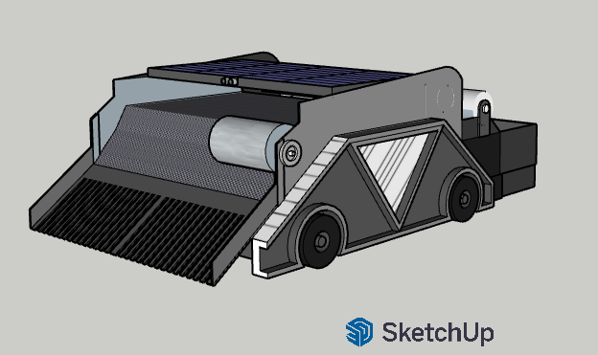
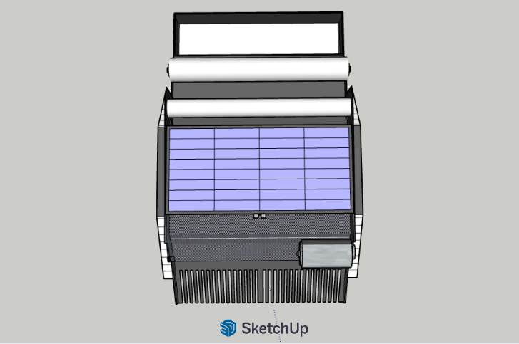

Figure 3. ISO View Figure 4. Top View
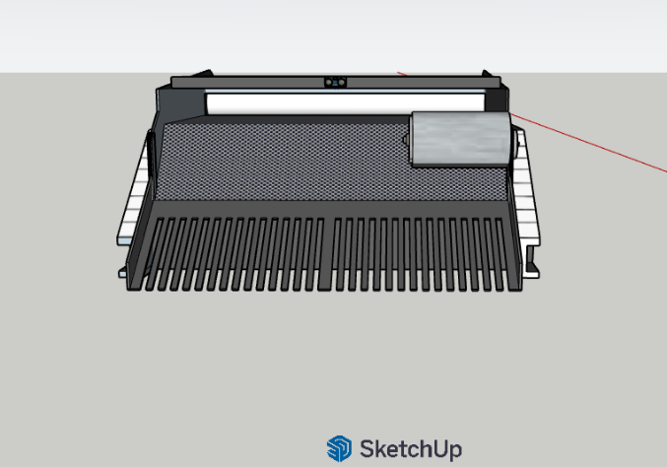
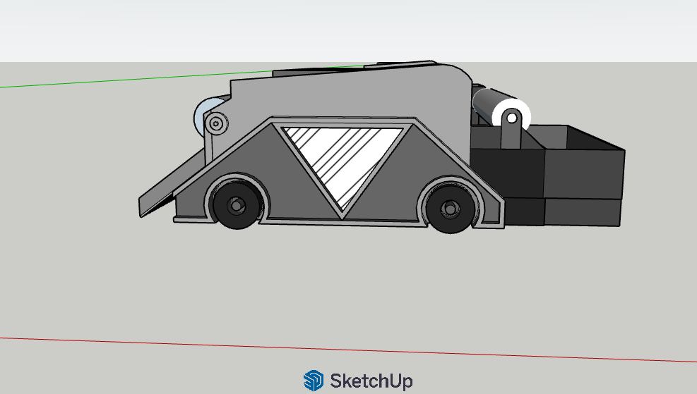

Figure 5. Front View Figure 6. Right View
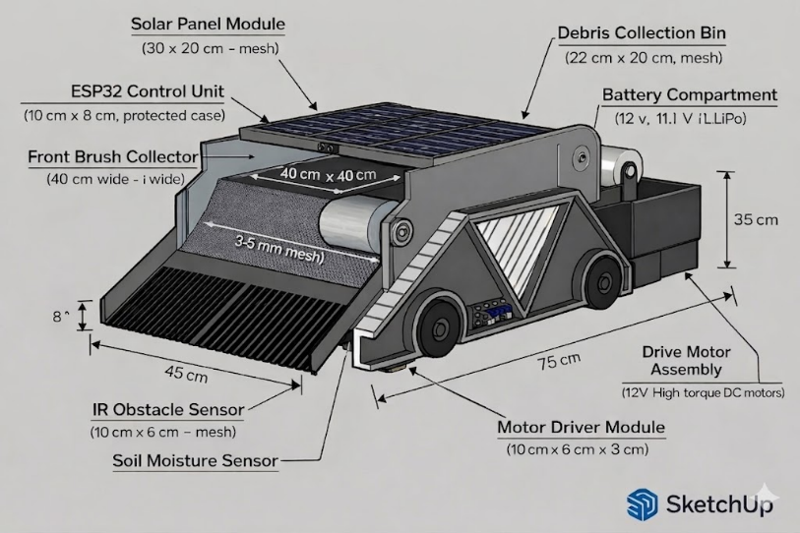
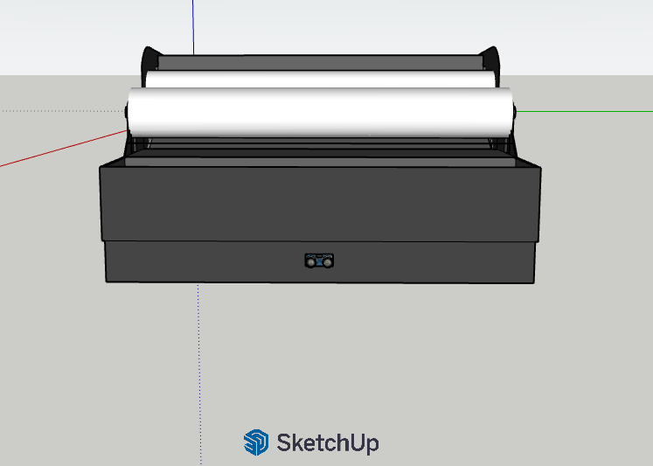

Figure 7. Left View Figure 8. ISO View with Components

